Serverless Architecture: Video Playback using Lambda and S3

**Overview**

* A serverless solution to stream video stored in Amazon S3 using AWS Lambda triggered by Amazon API Gateway.
* This setup ensures scalability, minimal maintenance, and secure access to video content.

**Architecture Components**

* Amazon S3 - Stores the video file.
* AWS Lambda - Fetches video and serves it via API request.
* API Gateway - Triggers Lambda via HTTP endpoint.
* IAM Roles - Provides necessary permissions for Lambda to access S3.

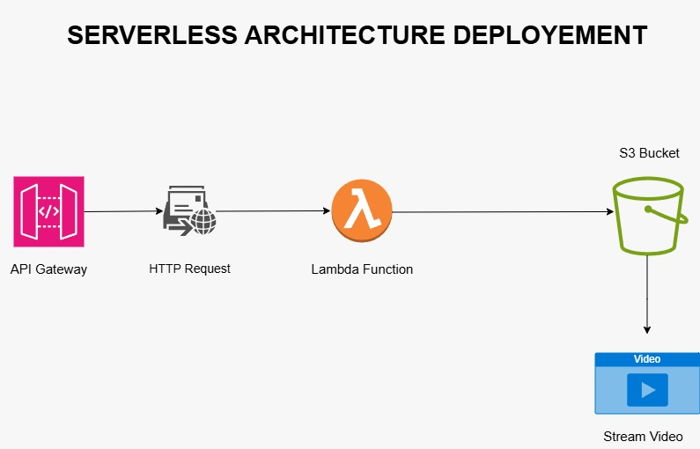

**Workflow**

* 1. User hits API Gateway endpoint.
* 2. API Gateway invokes Lambda function.
* 3. Lambda accesses video file in S3.
* 4. Video is streamed via a pre-signed URL or direct response.

**Key Features**

* No server management required.
* Automatic scaling based on traffic.
* Secure access using IAM and signed URLs.

**Deployment Overview**

* 1. Upload video to S3 bucket.
* 2. Create Lambda function to fetch video.
* 3. Grant Lambda access to S3 via IAM.
* 4. Create API Gateway endpoint and link it to Lambda.
* 5. Deploy and test using endpoint URL.

**Best Practices**

* Use pre-signed URLs for large files to avoid timeout.
* Enable CloudWatch logs for monitoring.
* Secure API access with API keys or IAM roles.
* Use environment variables for bucket names and keys.

**Testing and Access**

* Use browser, Postman or CURL to hit API endpoint.
* Pre-signed URL can be opened in HTML video player.
* Check CloudWatch logs for debugging.

**Conclusion**

* This serverless architecture enables efficient and scalable video delivery using AWS services with minimal cost and operational overhead.